# CMPG 223 Prototype(s) Group Assignment

## OpenMind System

**Group members**:

1. Thato J Mokoena 27268217

2. Sandra N Ezeh 34615199

3. Benny T Kwinana 34862145

4. Rosemery Mhlanga 34282963

5. Khensani W Molefe 32599463

Contributions: Designs were shared amongst group members in the following manner.

|  |  |
| --- | --- |
| **Group Member (Student number)** | **Member Contributions** |
| Thato J Mokoena (27268217) | All 3 login pages including teacher and admin pages. |
| Sandra N Ezeh (34615199) | All 3 register pages. |
| Benny T Kwinana (34862145) | All 3 maintain gradebook pages. |
| Rosemery Mhlanga (34282963) | All 3 assign marks pages. |
| Khensani W Molefe (32599463) | All 3 maintain pages for the admin, teachers and learners. |

**Login Pages:**

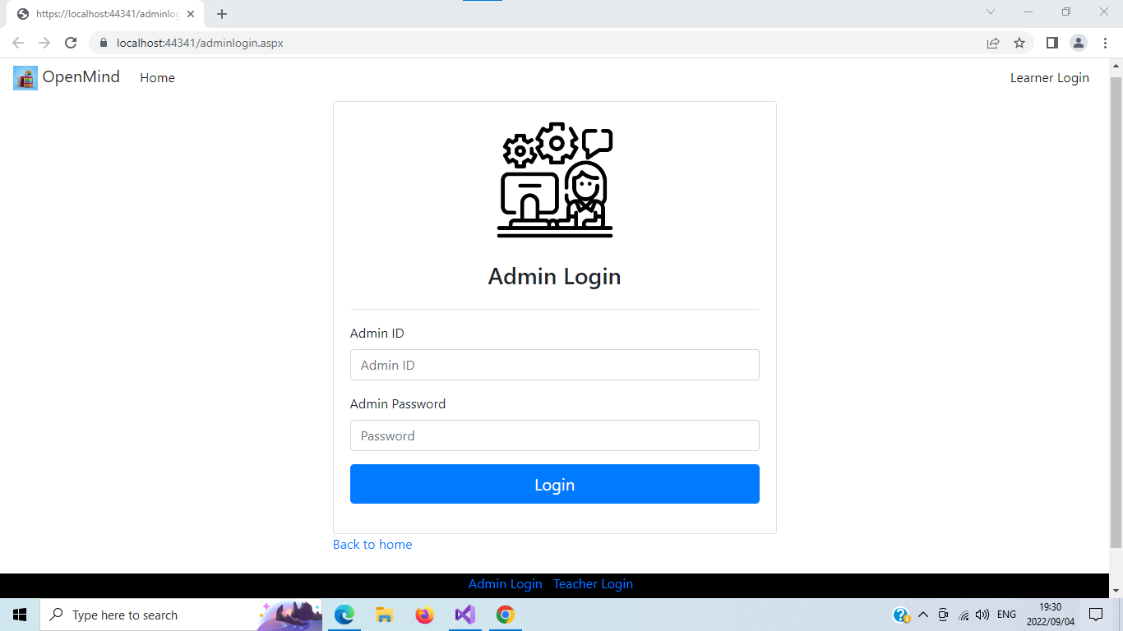

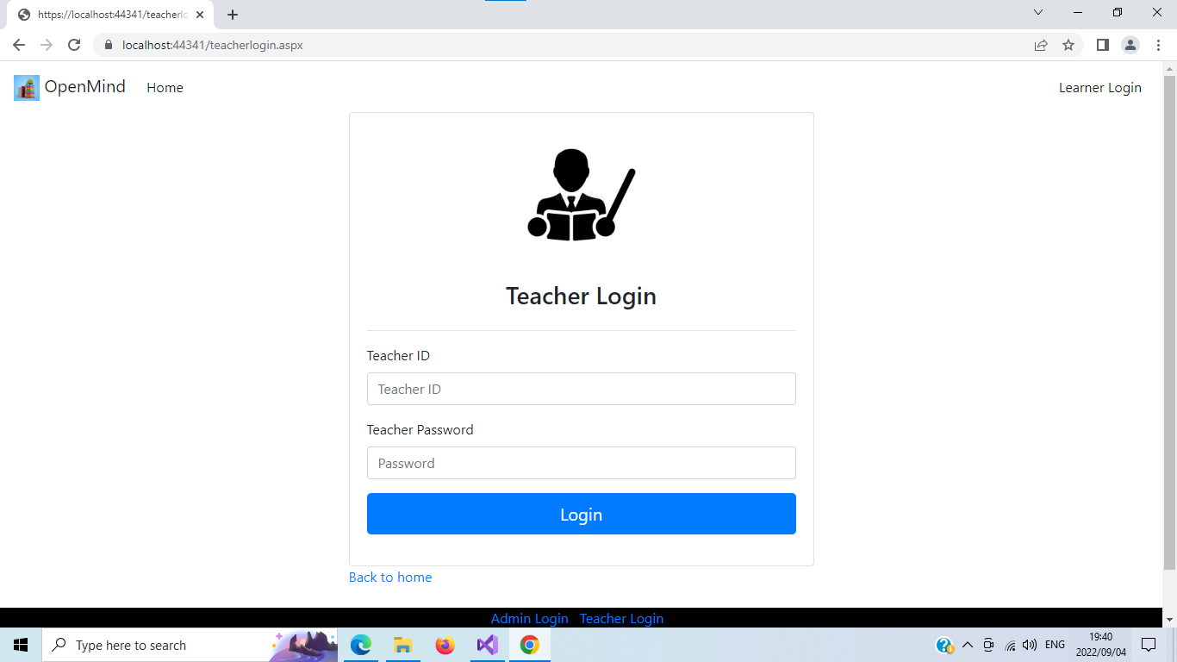

*Both the admin and teacher should select what they want to do after they are logged into the system.*

**Admin & Teacher Pages:**

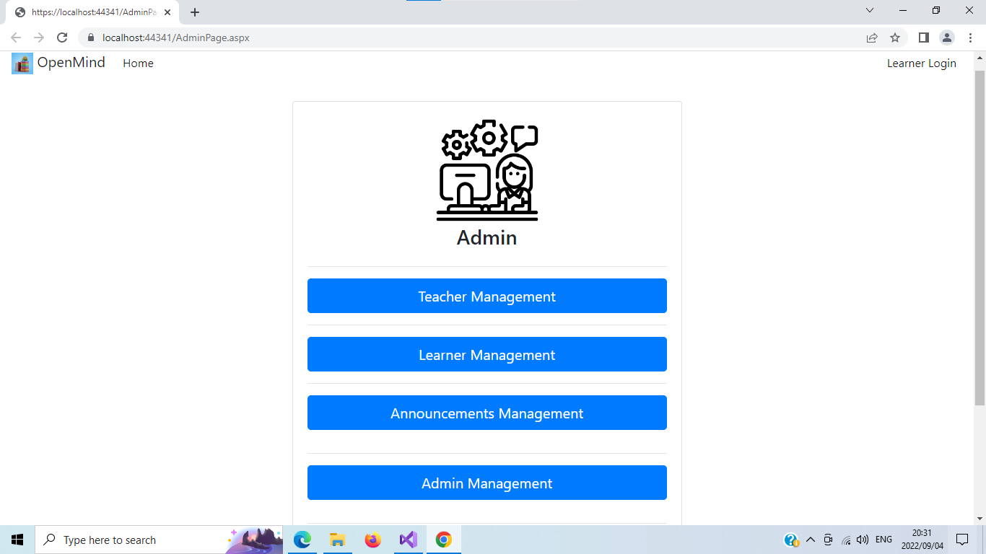

**Register pages:**

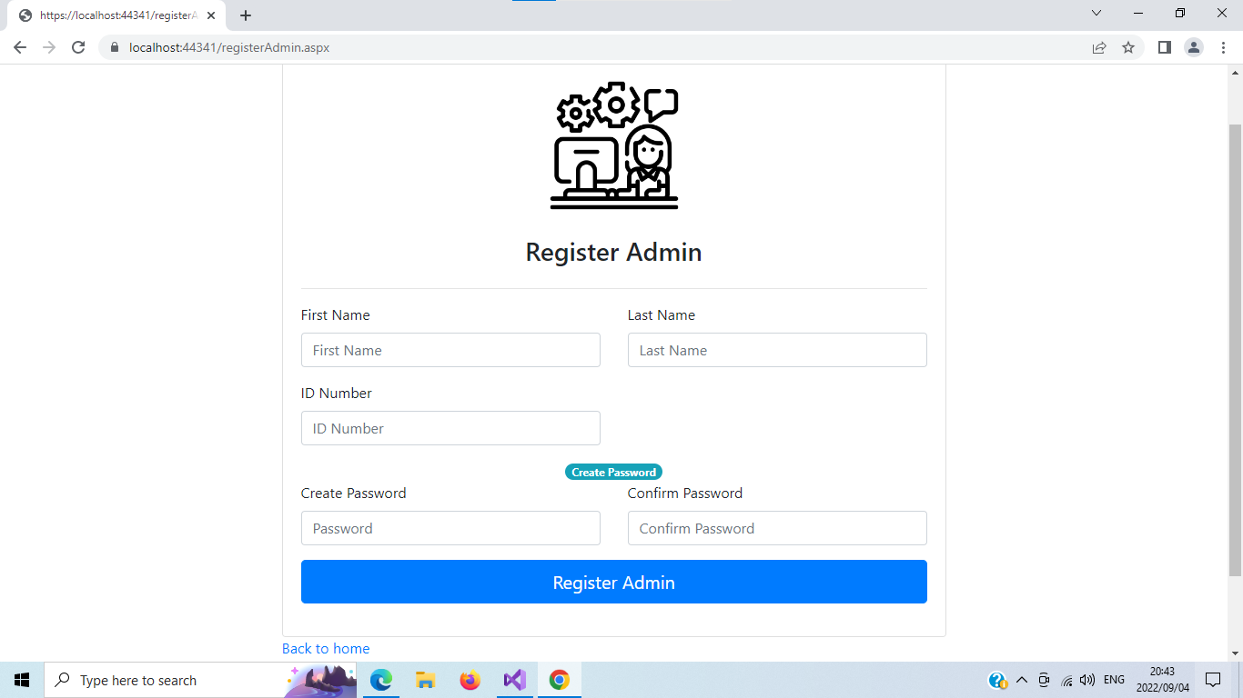

**Maintain Gradebook Pages:**

*The details side is to display table for the listing marks of all the learners, after adding/Updating/Deleting.*

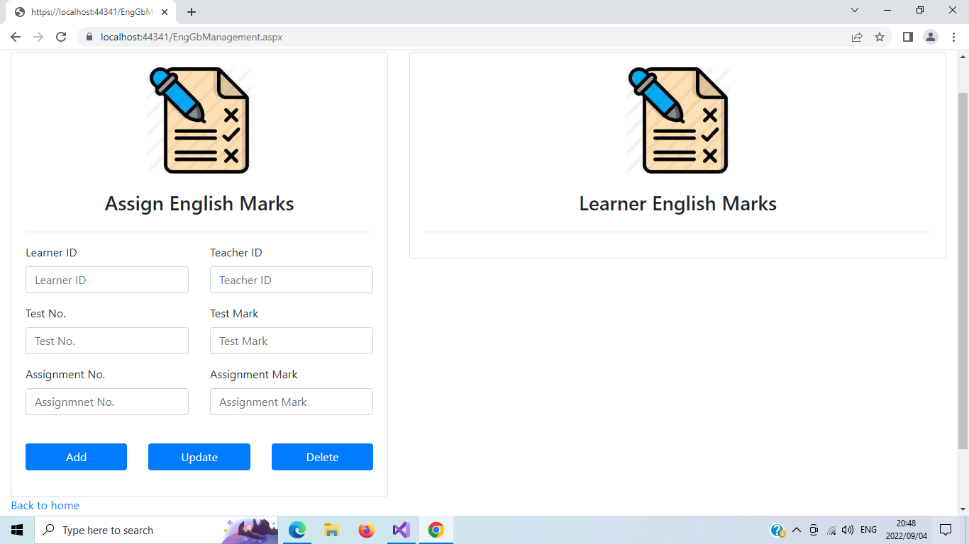

**Assign Marks Pages:**

**Assign Marks Pages:**

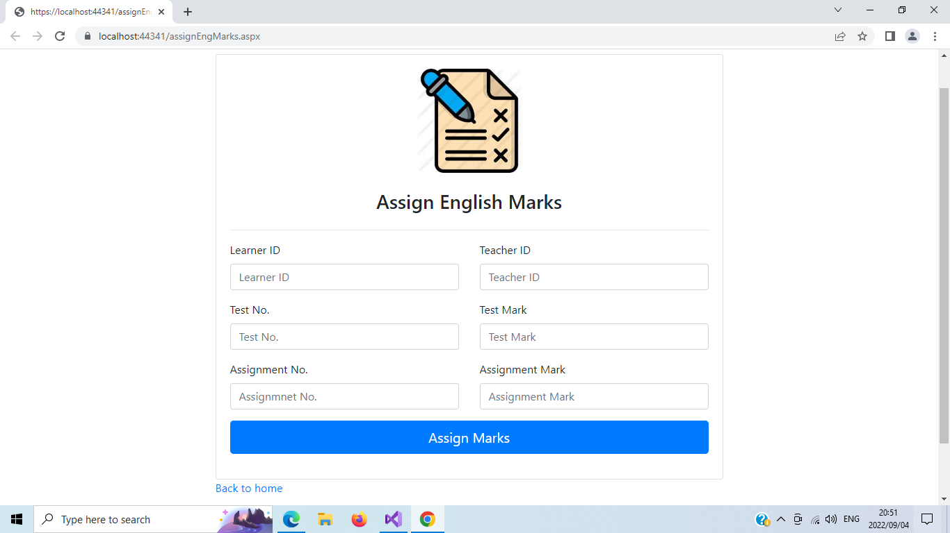

**Maintain Admin, Teachers & Learners Pages:**

